**Question 1:**

● Create payload for windows .

● Transfer the payload to the victim's machine.

● Exploit the victim's machine.

ANSWER:

open the virtual box and power on the kali linux machine.

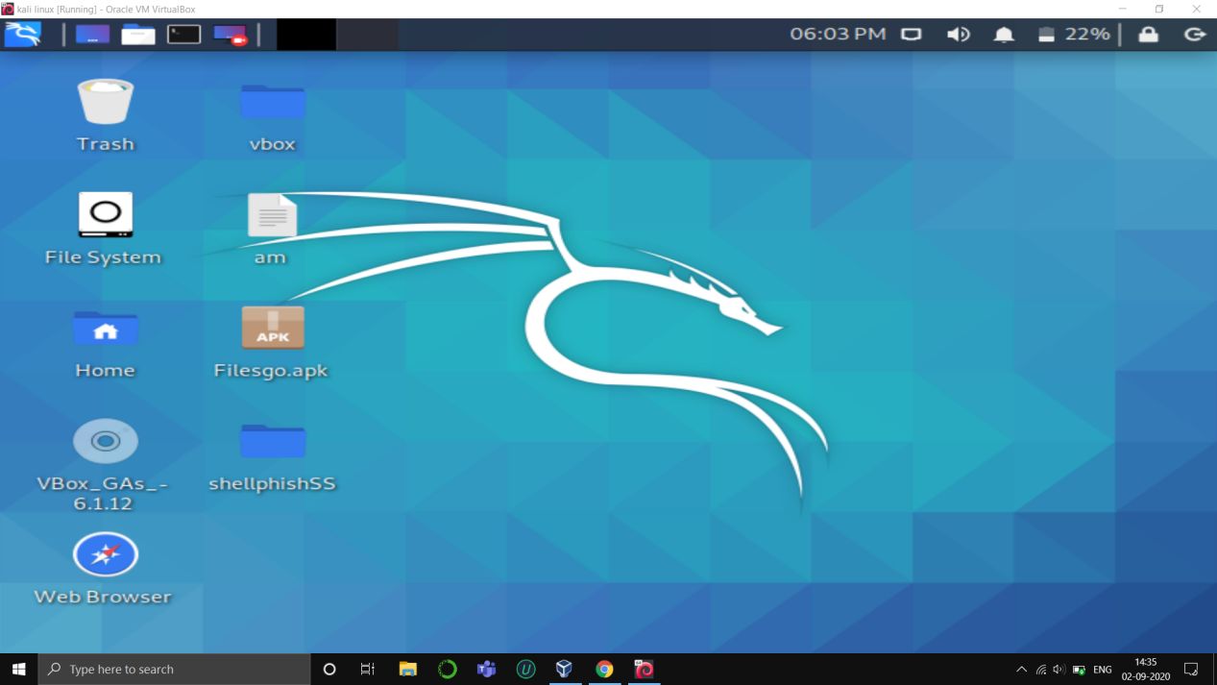

Open kali linux terminal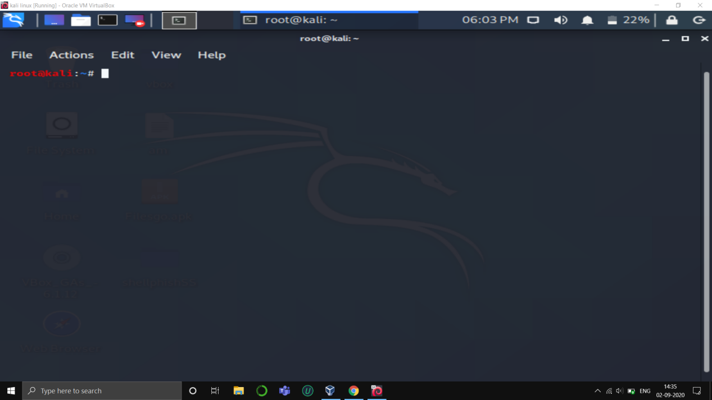

Type the windows payload command.

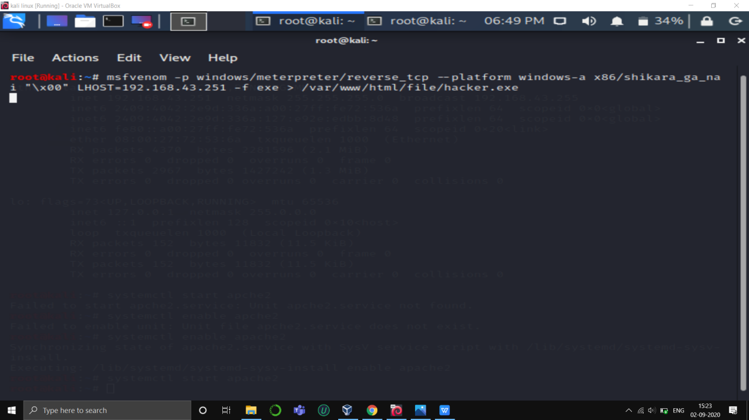

Payload generated sucessfully.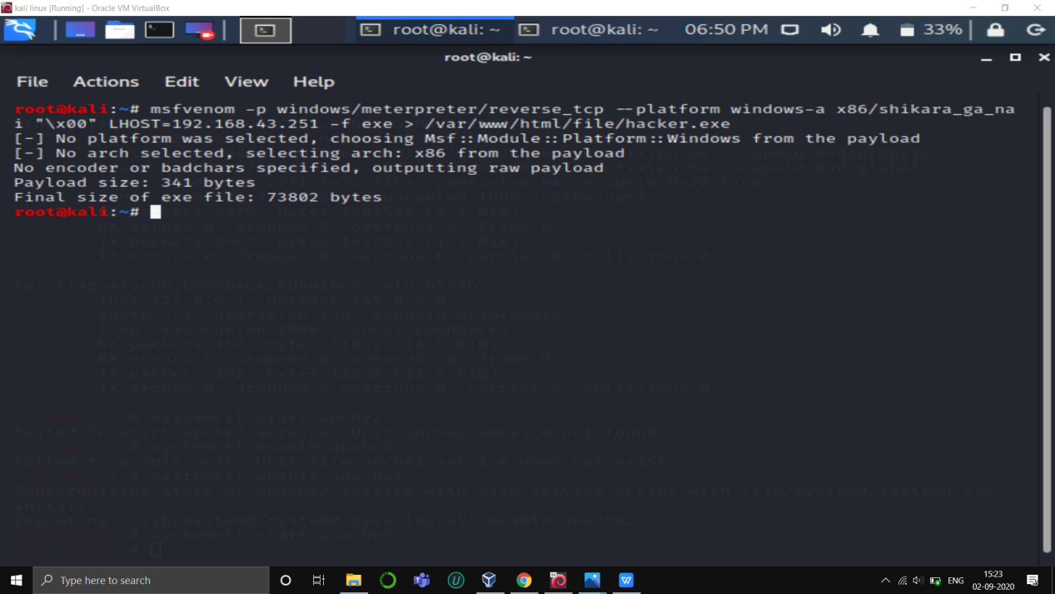

Now start the apache2 server so that we can directly access file through internet.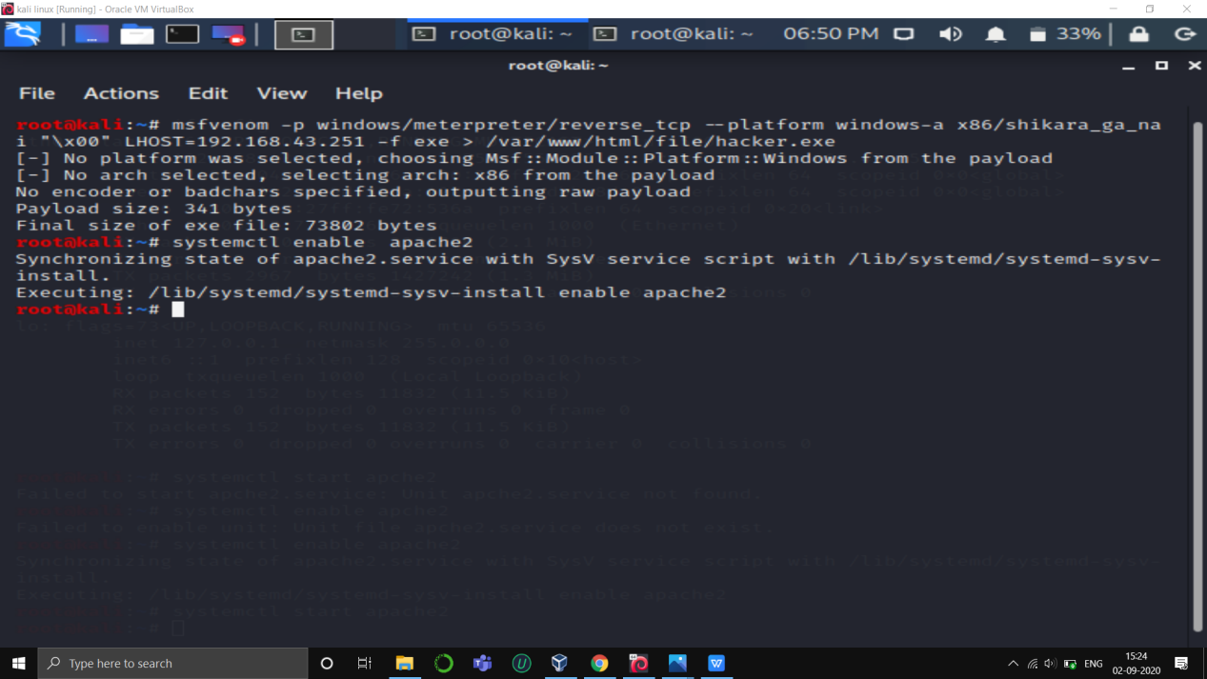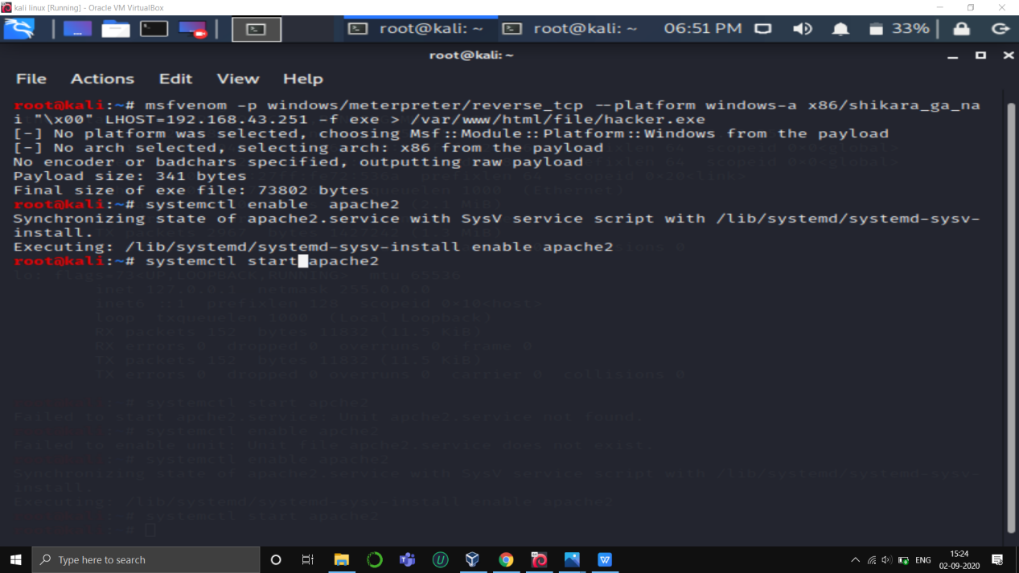

now we can access the payload through internet,in victim operating system with address ip/file name.

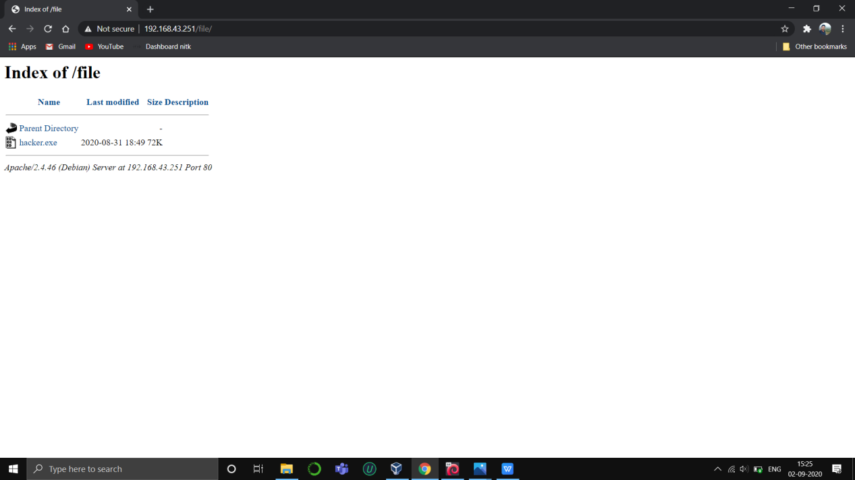

We can directly download file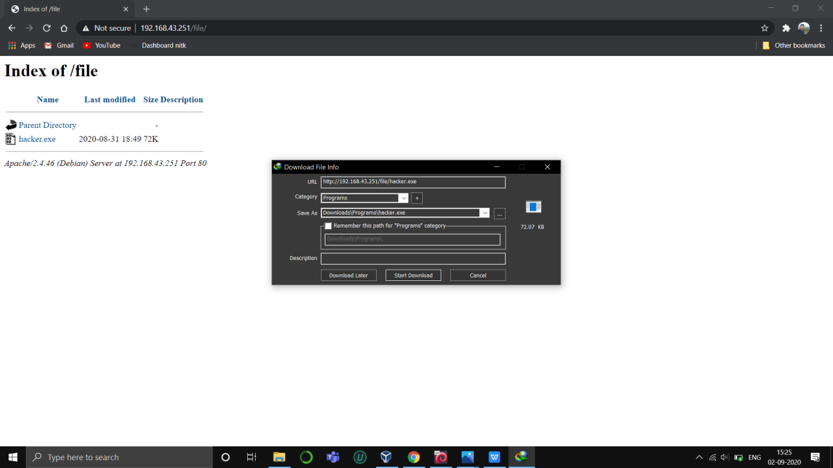

Open the kali terminal type msfvenom to open metaspoitable

And gain access of victims os.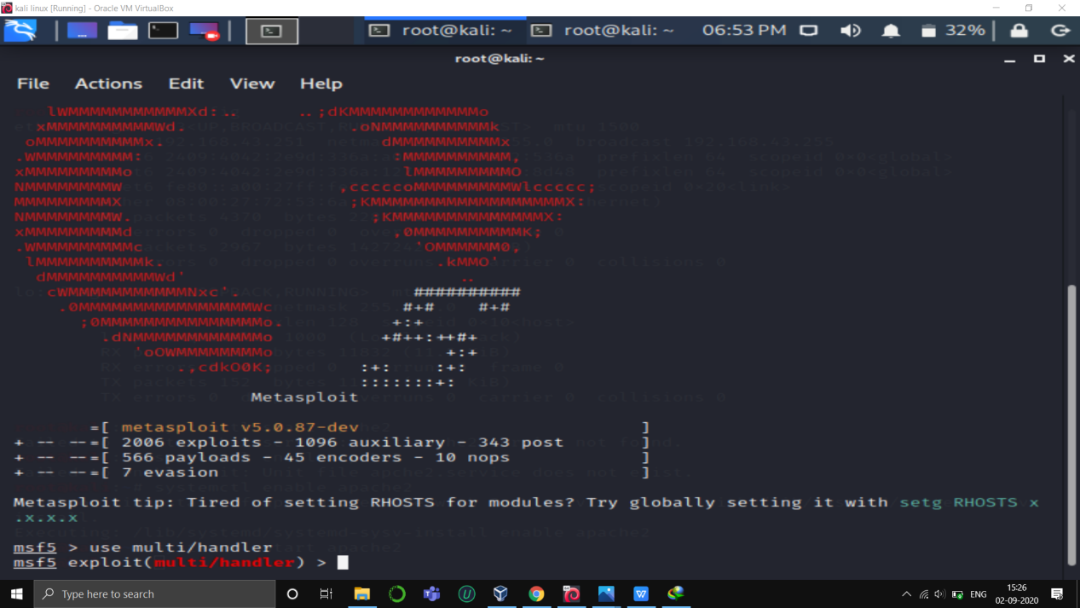

Set payload windows/meterpreter/reverse_tcp

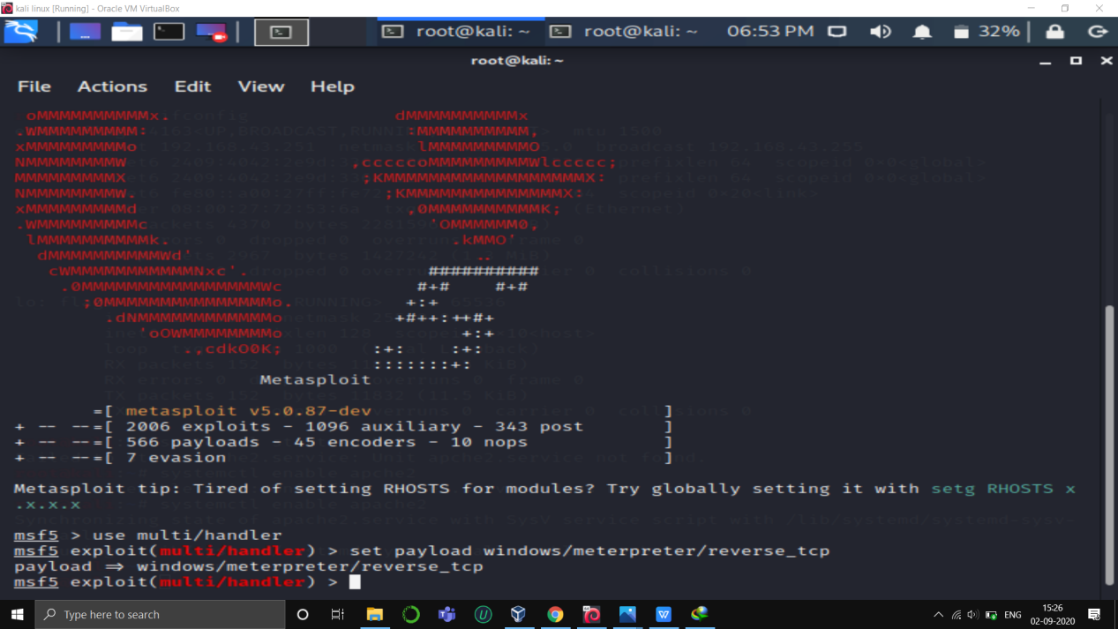

Check for the options lhost lport with show options.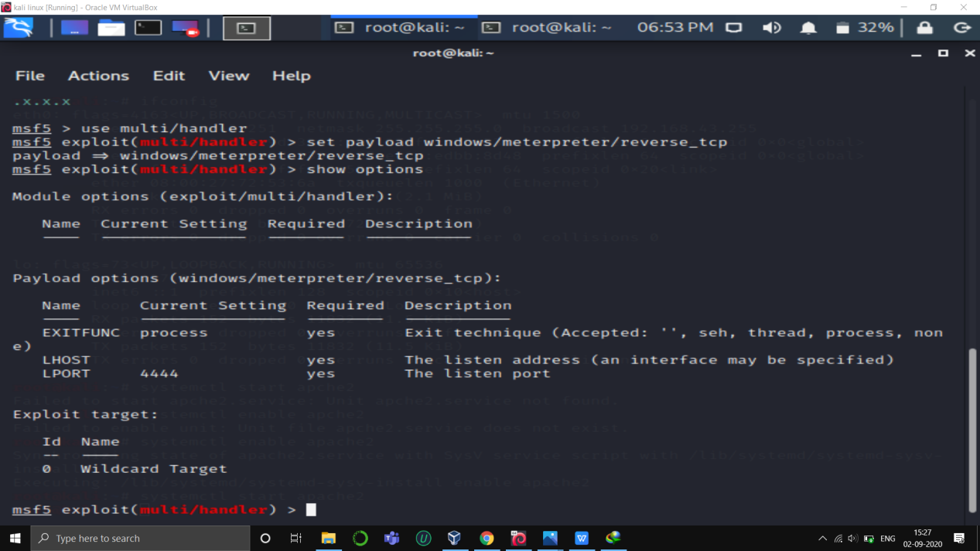

Set the lhost as ip address.

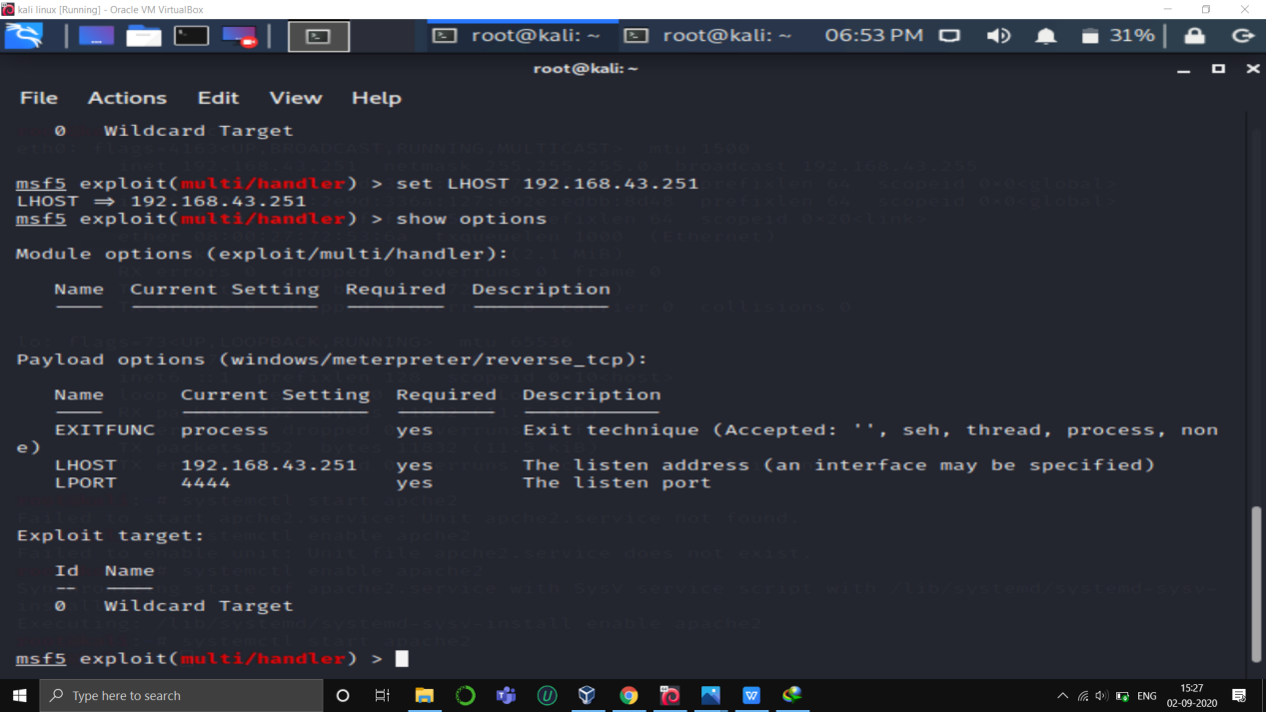

Exploit the victims os.

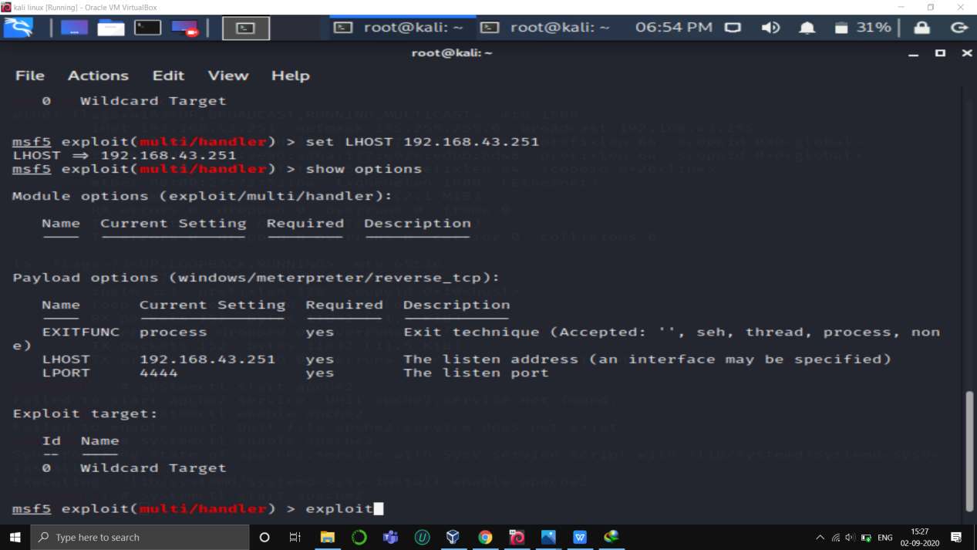

And we successfully get the victims machine access.

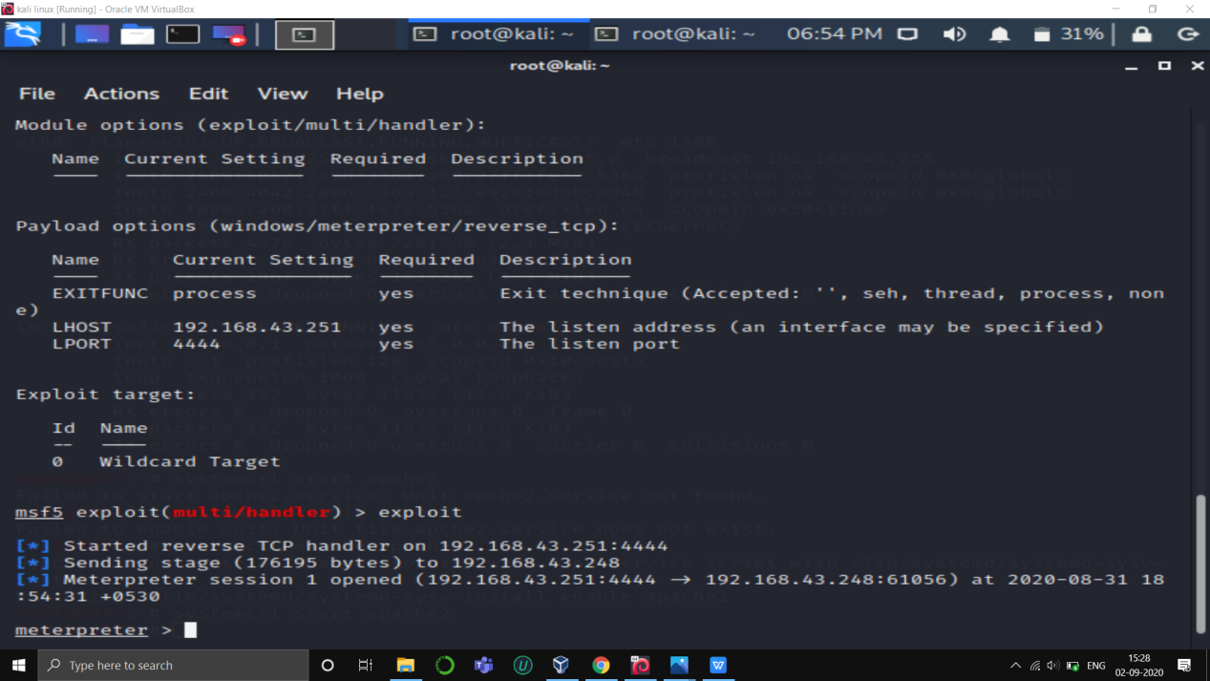

We can use many command to operate the victims os.like screenshot, shell,sysinfo.

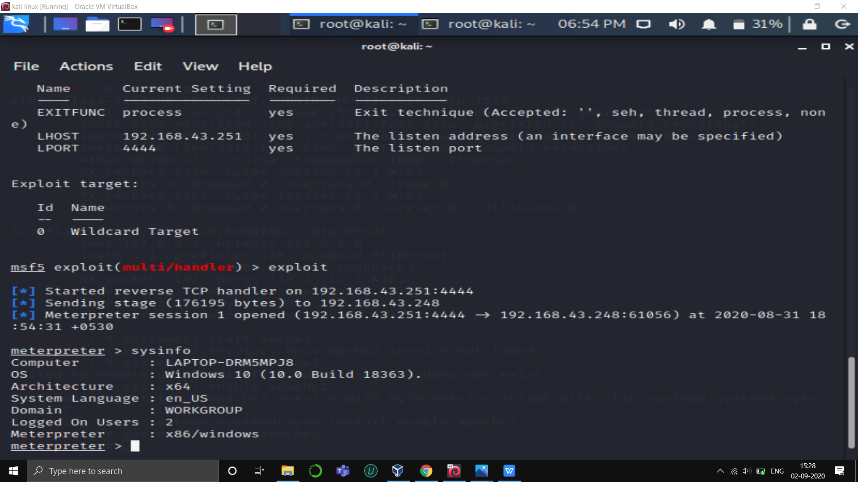

**Question 2:**

● Create an FTP server

● Access FTP server from windows command prompt

● Do an mitm and username and password of FTP transaction using wireshark and dsniff.

ANSWER:

Firsly open the kali linux machine and update the repositories.



Type the command to get vsftpd installed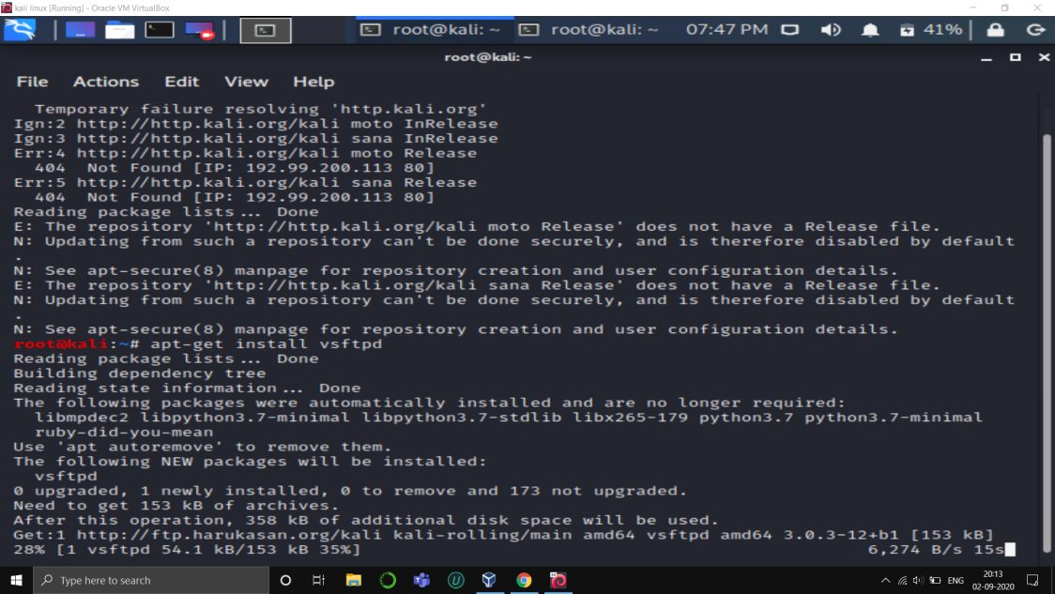

After that open the vsftpd with to make nessecery changes.

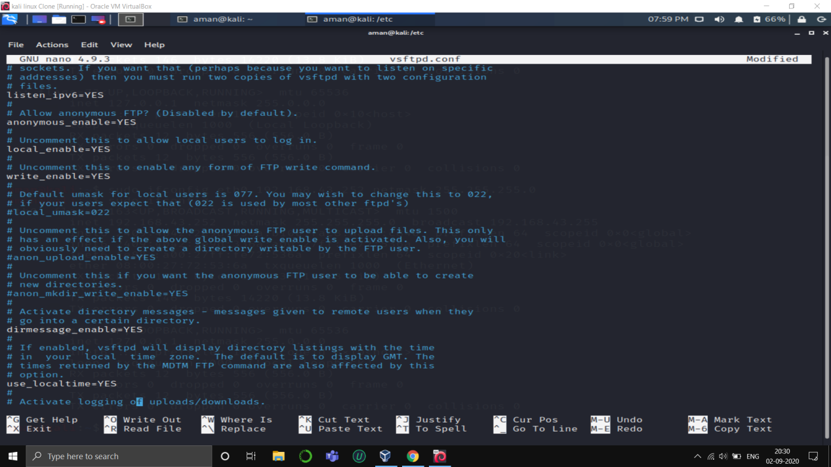

Add newuser and paste the text copied from vsftpd file.

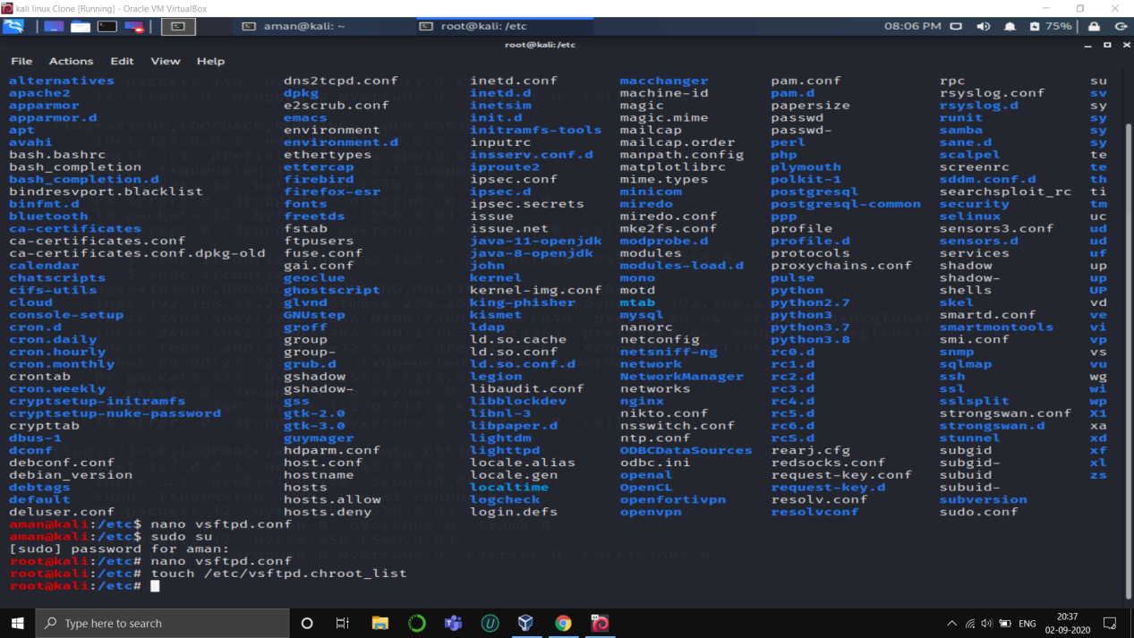

Give the cmd service vsftpd start

Check for open ports with nmap localhost command.we wiil get ftp as open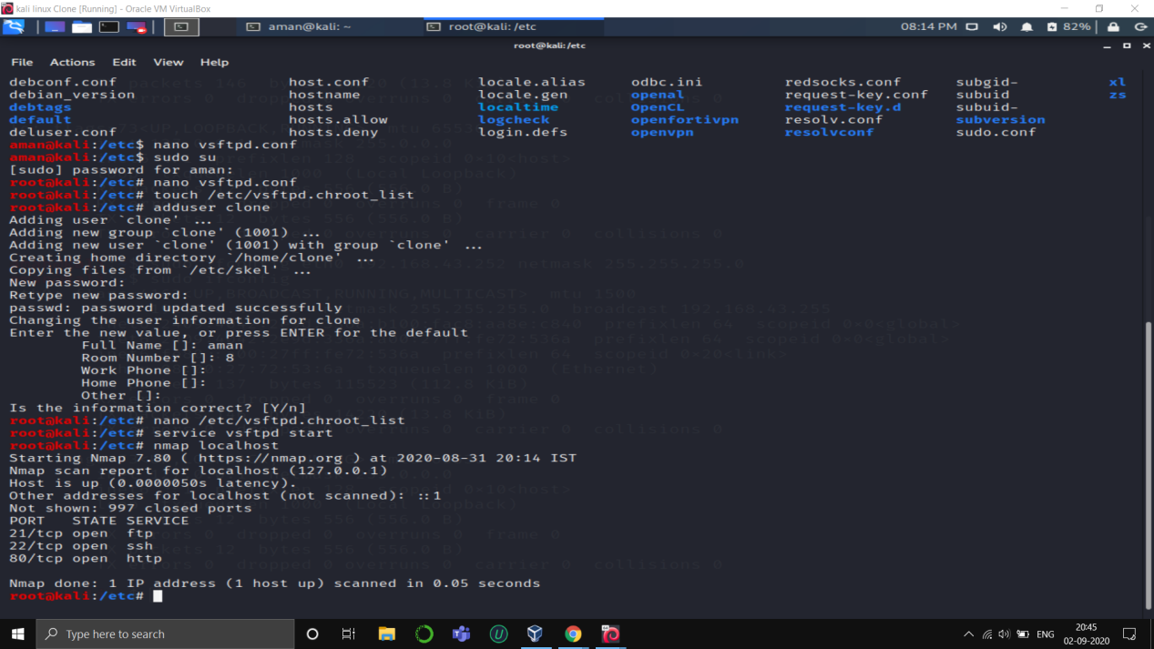

Now with cmd ftp localhost we will get access

